For Immediate Release
Tel Aviv Museum of Art Presents
Jeff Koons: Absolute Value
From the Collection of Marie and Jose Mugrabi

Showcasing over three decades of works by renowned artist and cultural phenomenon, Jeff Koons, Absolute Value highlights Koons’s extraordinary career, from the 1980’s until today

Curator Doron Rabina
Associate Curator: Shahar Molcho
March 10 – October 10, 2020
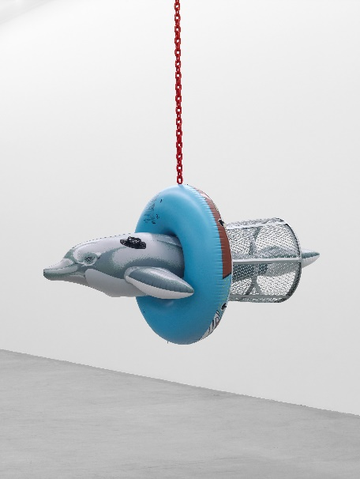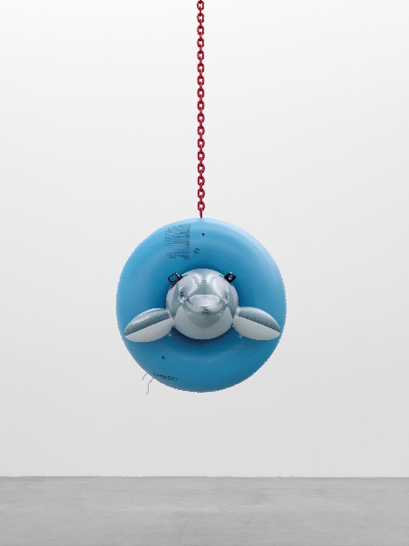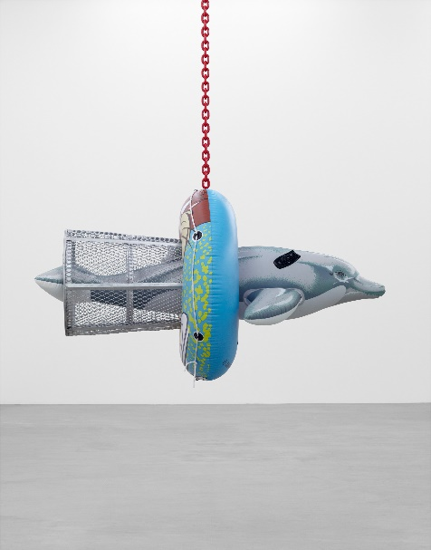
Images: Jeff Koons, Dolphin Taz Trashcan, 2007–11 polychromed aluminum, galvanized steel, coated steel chain
42 x 42 x 77 1/4 inches 106.7 x 106.7 x 196.2 cm. ©Jeff Koons, Photo: Marc Domage

Tel Aviv Museum of Art presents Absolute Value, showcasing the works of American artist Jeff Koons, a world-renowned cultural phenomenon who explores themes pertaining to banality, consumerism, mass culture and beauty, resonating far beyond the confines of the art world. Curated by Doron Rabina, Chief Curator of Tel Aviv Museum of Art, Absolute Value offers a glimpse into Koons’s diverse spectrum of mediums and techniques, through the eyes of the collector, from different periods in the artists’ extraordinary career. Koons’s first solo exhibition in Israel showcases some of his most prominent works from the last three decades.
Absolute Value features twelve large-scale works, from iconic series - such as Bear and Policeman (1988) from the Banality series; Dolphin Taz Trashcan (2007–11) from the Popeye series, and Hulk (Rock) (2004–13) from the Hulk Elvis series. Balloon Venus Dolni Vestonice (Violet) (2013–17), from the Antiquity series, references the history of art, a recurring subject in Koons’s recent work. The exhibition will also unveil Ballet Couple (2010-19), which has been in development for the past ten years and will be unveiled for the first time.

“The Tel Aviv Museum of Art is proud to host one of the greatest artists of our time, Jeff Koons - a prominent and influential figure in contemporary culture” says Director Tania Coen-Uzzielli. “We are delighted to present Koons’s first solo exhibition in Israel, marking a significant cultural milestone in our country. I would like to thank Jose Mugrabi for his remarkable generosity in making this exhibition possible, offering our visitors the opportunity to experience these spectacular works of art."
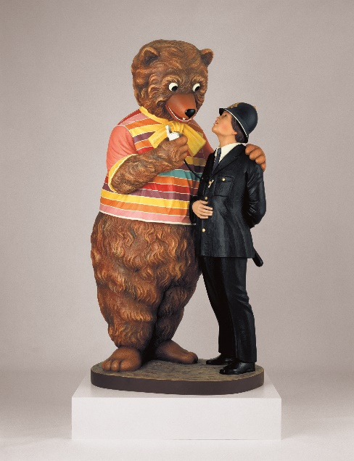 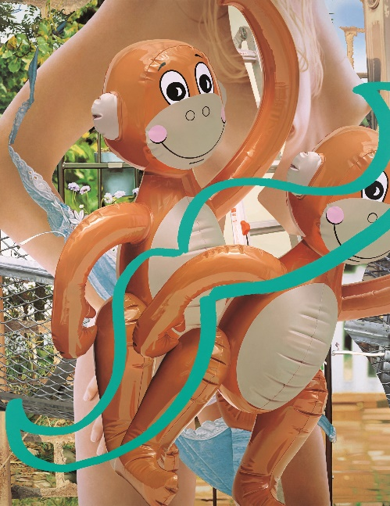
Images: (Left) Jeff Koons, Bear and Policeman, 1988, polychromed wood, 85 x 43 x 37 inches, 215.9 x 109.2 x 94 cm © Jeff Koons;
(Right) Jeff Koons, Monkeys (Ladder), 2003, oil on canvas, 108 x 84 inches, 274.3 x 213.4 cm © Jeff Koons, Photo: Tom Powel Imaging

As one of the most influential artists of our times, Koons who emerged in the 1980s, explores the meaning of art and spectacle in a media-saturated era, while accentuating in his aesthetics the consumer culture that arose at this time. Absolute value is a mathematical concept, denoting size in numerical terms: the absolute value of a number is the distance between it and the zero point on the number axis. The use of this notion in the exhibition’s title raises the question of value as a fundamental notion in Koons’s art, both in meaning and numerically. The title places Koons himself - the artist and the phenomenon - as the axiom of contemporary art; an artist who is an irrepressible phenomenon, a symbol of the era.

Jeff Koons: Absolute Value will be on view throughout the Tel Aviv Museum of Art’s largest exhibition space, the Lilly & Yoel Moshe Elstein Multi-Purpose Gallery in the Herta and Paul Amir Building, covering 850 square meters.
---

Notes to Editors
For press inquiries or high-resolution images, please contact Jacob Peres Office: Omer Shachar, omer@jpoglobal.com

The exhibition Jeff Koons: Absolute Value – from the Collection of Marie and Jose Mugrabi is the second collaboration between the Tel Aviv Museum of Art and the Jose and Marie Mugrabi Collection, some of which works were exhibited in 2013 in the Wanted exhibition including works by Andy Warhol, Jean-Michel Basquiat, Richard Prince, and others.
About Jeff Koons
Jeff Koons (born 1955, York, Pennsylvania, lives and works in New York City) studied at the Maryland Institute College of Art in Baltimore and the School of the Art Institute of Chicago. He received a BFA from the Maryland Institute College of Art in 1976. Since his first solo exhibition in 1980, Koons’s work has been shown in major galleries and institutions throughout the world. A full survey of Koons’s career was the subject of a major exhibition at the Whitney Museum of American Art in New York in 2014, which travelled to the Centre Pompidou in Paris and to the Guggenheim Museum Bilbao.

About Tel Aviv Museum of Art
The Tel Aviv Museum of Art is one of Israel's leading artistic and cultural institutions. The Museum's primary mission is to collect, preserve and display modern and contemporary art by Israeli and international artists. It aims to stimulate cultural and artistic dialogue between past and present, and to explore both canonical and experimental endeavors. It constitutes a platform for visual culture that encompasses fine arts, design, architecture, performance, music and theatre. It is committed to cultivating an artistic and cultural environment that is accessible to a wide range of audiences. Its educational program aims to inspire new ways of learning through its collections, temporary exhibitions and cultural programs and to engage with the future generation of museum goers. Welcoming over one million visitors in 2019, it is among the 100 museums with the highest attendance in the world.

